Date access: 2020-03-10

<http://wjw.beijing.gov.cn/wjwh/ztzl/xxgzbd/gzbdyqtb/202001/t20200131_1621808.html>

From 8 am to 20 pm on January 30, 7 new cases of pneumonia infected with new coronavirus were reported in this city and 1 was discharged

Date: 2020-01-31 Source: Beijing Municipal Commission of Health

From 8 am to 2 pm on January 30, 7 new cases of pneumonitis infected with new coronavirus were reported in the city, 2 of which had contact history in Hubei and other provinces, and 5 were close contacts of confirmed cases, all of which have been sent to the city. Level designated medical institutions for treatment.

As of 20:00 on January 30, a total of 121 confirmed cases were confirmed in the city, including 1 death, 5 discharges, and 115 cases of isolation and treatment at designated municipal hospitals. 2 in Dongcheng District, 12 in Xicheng District, 21 in Chaoyang District, 24 in Haidian District, 11 in Fengtai District, 2 in Shijingshan District, 1 in Mentougou District, 10 in Tongzhou District, 2 in Shunyi District, 15 in Daxing District, There were 9 cases in Changping District, 1 case in Huairou District, and 11 cases came from overseas. No cases have been reported in Fangshan District, Pinggu District, Miyun District, and Yanqing District.

**1月30日8时至20时，本市新增7例新型冠状病毒感染的肺炎病例， 出院1例**

日期：2020-01-31 来源：北京市卫生健康委‍

        1月30日8时至20时，本市新增7例新型冠状病毒感染的肺炎病例，其中2例有湖北及其他省份接触史，5例为确诊病例的密切接触者，均已送至市级定点医疗机构进行救治。

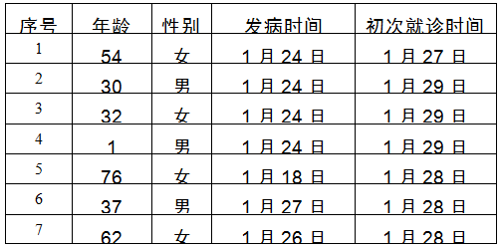

        截至1月30日20时，本市累计确诊病例121例，其中死亡1例，出院5例，115例在市级定点医院进行隔离治疗。东城区2例、西城区12例、朝阳区21例、海淀区24例、丰台区11例、石景山区2例、门头沟区1例、通州区10例、顺义区2例、大兴区15例、昌平区9例、怀柔区1例，外地来京人员11例。房山区、平谷区、密云区、延庆区尚未有病例。